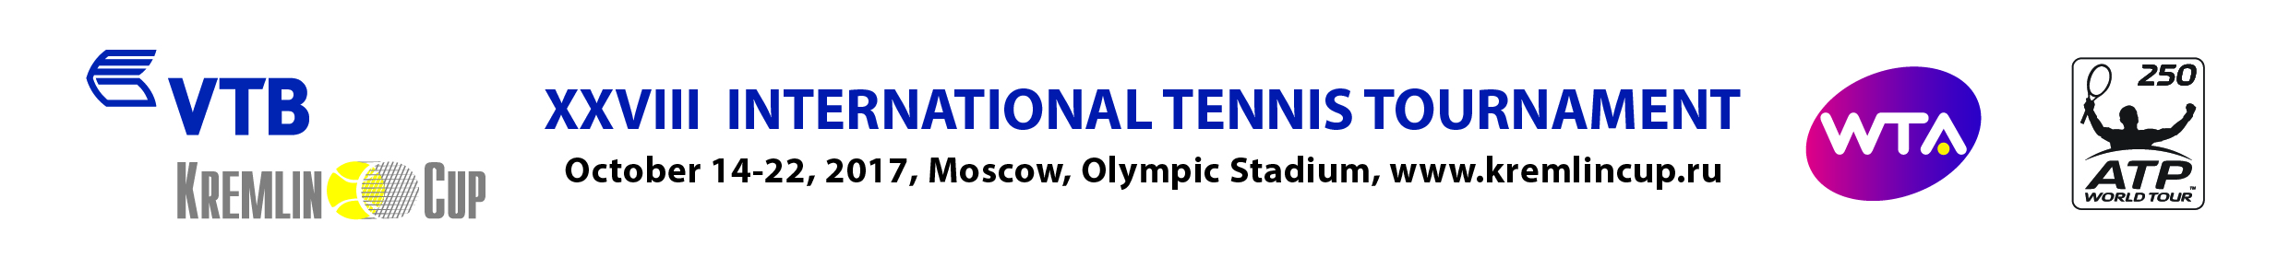

ACCREDITATION FORM FOR PHOTOGRAFER
MEDIA (№ Registration Certificate)
Family name: |  |  |  |  |  |  | Name:
Surname:
Address:
Mobile phone: |  |  |  |  |  |  | Email:
Type of Media:
 |  | Printing press |  |  |  | Information Agency |  |  | Blog |  |  | Other ______________
 |  | Radio |  |  |  | Internet |  |  | TV
Position::
Photographer

Preferable dates for Accreditation to the Centre Court:
 |  | 16.10. |  | 18.10. |  | 20.10. |  | 22.10.
 |  | 17.10. |  | 19.10. |  | 21.10.

ATTENTION: to get accreditation fill in all the fields in the Form, attach a scanned copy of the Company letter (pdf) and photos (preferably 300 dpi, jpg, 4*6 cm).

* October 14-19: Free entrance to the Centre court without extra Accreditation.
October 20-22: Entrance to the Centre Court only against two Accreditations:
    - Accreditation “PHOTO” for whole duration of the Tournament
- Daily Accreditation “PHOTO” to the Centre Court where the Date and seat number in the working area are indicated (Tribunes D8-D11).

All materials should be submitted not later than October 1st, 2017 to the following e-mail address: natalia.ivanyuk@russport.ru
- Tournament organizing Committee keeps the right not to issue accreditation for no reason.
- Applications submitted after the deadline and applications from the representatives of advertising agencies will not be accepted.

If your Application for Accreditation is approved you will receive conformation to your e-mail address.

Approval of the Head
Signature of the Director and Stamp |  |  |  |  |  |  |  |  |  |  | Date

VTB Kremlin Cup
Press Service
tel: + 7 495 956 33 60
natalia.ivanyuk@russport.ru

